Netflix failed to flag 'strong suicide themes' for 13 Reasons Why
14 August 2018

- It took government intervention for Netflix to warn Australian parents about "strong suicide themes" in the first season of 13 Reasons Why.
The global streaming giant originally gave the confronting television series an MA15+ rating on the grounds it portrayed strong sex scenes and violence.

However, the Classifications Board reviewed the decision and ruled 13 Reasons Why should be restricted to people aged 15 years and over because of "strong suicide themes and sexual violence". As a result, Netflix amended its consumer advice for Australian audiences.
The ratings watchdog said parents should be warned about the strong suicide themes given the show depicts – in graphic detail – the method in which main character Hannah Baker kills herself, according to documents released under freedom of information.

A previous episode depicts the same actor, played by Australian Katherine Langford, being raped in a hot tub.

Mental health groups raised concerns about the first season of 13 Reasons Why - and so did the ratings watchdog.

Last year, Australia's peak mental health organisations raised concerns about 13 Reasons Why. Among their grievances was the fact Netflix did not list the contact information for local support services, as is widely done in Australia.
While the creators of 13 Reasons Why stood by their show – even pointing out they consulted with medical professionals – Netflix changed its approach for the release of the second season. This time around, viewers were directed to a website that listed the contact details for suicide prevention services.
Child and adolescent psychologist Dr Michael Carr-Gregg said the majority of young people who watch 13 Reasons Why won't be profoundly affected. But he said there is "definitely a contagion affect" that has been documented for people with pre-existing mental health conditions.
"A man rang me from Canberra not long after the show went to air and said his daughter had watched this without his knowledge or consent and said she had popped herself in the bathtub and [attempted suicide] in the same way as Hannah does in 13 Reasons Why," he said.

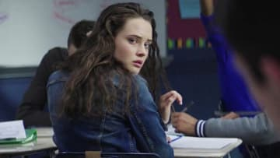

"I think the least we can do is give consumers adequate warning."
The Classifications Board randomly audits Netflix's in-house ratings. However, high-profile films and TV shows – as well as those perceived to be controversial – are automatically put under scrutiny.
A Netflix spokeswoman said the streaming giant will continue to work with the government watchdog in order to produce ratings that are "broadly consistent with classification decisions of the board and community standards".
The Department of Communications and the Arts declined to comment.

