The history of media regulation in Australia
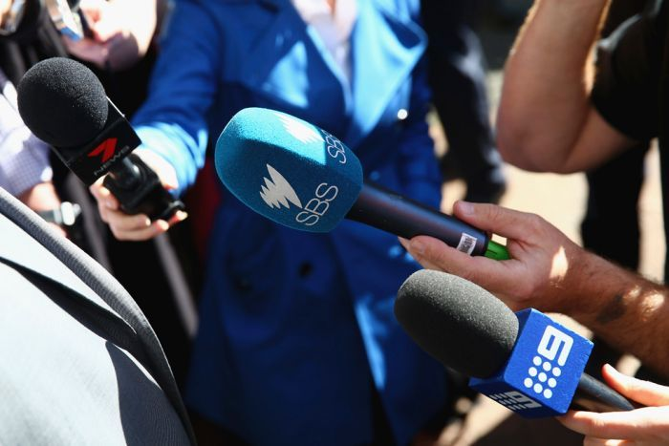 IMAGE: LARGE MEDIA COMPANIES HAVE CONSISTENTLY BENEFITTED FROM CHANGES TO MEDIA REGULATION IN AUSTRALIA. (RYAN PIERSE/GETTY IMAGES)

A diverse, independent media is seen as central to a functioning democracy, yet Australia now has one of the most concentrated media environments in the western world. Keri Phillips asks how we got here in the first place and whether it even matters now that we're all online.
Government regulation of the airwaves in Australia goes back to the 1930s, when the federal government began to issue licenses, first for radio and then, in the 1950s, for television. Licenses were issued to operators for a fee and under certain conditions. Apart from a period during colonial times, the ownership of newspapers was free of government regulation until the 1980s, when Labor governments under Bob Hawke and Paul Keating introduced changes that continue to define the media landscape 30 years later. There are very few places where the people who are the beneficiaries of regulation get to determine how the regulation happens to quite the same degree that it happens in the Australian media landscape.

ANDREW DODD, SWINBURNE UNIVERSITY OF TECHNOLOGY
The first change limited media ownership to just one type of media in a given market—print, radio or television. The second abolished the rule that no one could own more than two TV stations and replaced it with one limiting the reach of broadcast licenses to 75 per cent of the Australian population. For Andrew Dodd, the program director of journalism at Swinburne University of Technology, 1987 was a watershed year.
'Rupert Murdoch bought into The Herald and Weekly Times, and in doing that he acquired the company that his father had built up. He already had assets but then he came in and bought six metropolitan newspapers as well as a raft of community papers around the country. So here he was sitting on an absolute mountain of printed publications. In the same year, the Trade Practices Commission said that this really didn't create market dominance, which was an extraordinary finding.
'At around the same time, Paul Keating brought in cross-media ownership rules and you may have heard the terms he used—the queen of the screen and the prince of print. You could be one or other but not both. His idea was that we create diversity by allowing dominance within one medium but not dominance across lots of mediums.

'The one limit on that rule was that television license holders were not allowed to reach more than 75 per cent of the national viewing audience. He decided that you could build up one asset in very, very high concentration but you couldn't branch over into another.'

The new regulations led to a round of buying and selling. Flamboyant West Australian entrepreneur Alan Bond bought media assets—including the Channel Nine television stations in Sydney and Melbourne—from Kerry Packer, then one of Australia's media moguls, for more than $1 billion. The stated aim of these rules was to create greater media diversity in order to give Australians access to a wider range of ideas and voices, but was that the outcome?

'Its limitations became apparent very quickly with the emergence of the new medium—pay television,' argues Dodd. 'When pay-TV came along there was a fight between all the different providers—Austar, Galaxy, and the dominant player Foxtel—and Foxtel was a product of Telstra with 50 per cent ownership, Packer with 25 per cent ownership at that stage, and Murdoch with the remaining 25 per cent. It quickly became the dominant pay-TV player and made a mockery of the cross-media ownership rules because you were having a very prominent and dominant television service, albeit on pay-TV, but quarter-owned by the company that then owned the vast majority of our newspapers.'

From the mid-1990s under Liberal PM John Howard, there were a number of attempts to liberalise the media ownership rules. In 2007, with Helen Coonan as communications minister, there were two significant changes.

'Foreign ownership limits were scrapped,' explains Dr Andrea Carson, a lecturer in media and politics at the University of Melbourne. 'Up until that point there had been a 25 per cent foreign ownership cap, which had been increased previously from 15 per cent. In 1994, Fairfax had been taken over by Conrad Black from Canada, the since disgraced media proprietor, who had been successful in lobbying for the limit to be increased to 25 per cent, but then still found that wasn't enough.'
In addition, the Howard government changed the cross-media ownership rules to allow ownership of two out of three media types. As with the Hawke/Keating regulations, these changes provoked a frenzy of buying and selling, as private equity firms bought into the Australian market and Australian media owners used the money to expand their interests.
'Nine quickly got sold off, 50 per cent of it was sold off to a private equity company called CVC Asia Pacific,' says Dodd. 'Seven likewise sold off 50 per cent of its holdings. But that in itself wasn't the problem, what was happening was that these local media companies were selling off to raise money so they could buy other media assets.
'For example, [with] Channel Seven, Kerry Stokes used the money that he'd acquired from selling off half of the company to buy the West Australian newspaper group, so that in Perth you had the guy who owned the TV station owning the newspaper, also owning the regional and community newspapers that came with it, as well as the online news service that came with the newspaper.'
'In radio, much the same thing happened, the Macquarie group bought into Southern Cross radio, and in a very complicated arrangement, Fairfax then grabbed Southern Cross's metropolitan radio stations. Quickly we had the situation where in Melbourne the great commercial radio station 3AW was owned by the newspaper company Fairfax. We had The Age and 3AW literally located in the same building with the same owner, another diminution of voices in the marketplace.'
In 2011, with Julia Gillard as prime minister, the Labor government attempted a root and branch rethinking of regulation to try to take into account a media environment that now included the internet. The Convergence Review attempted to come up with a way to address powerful emerging media while also creating some commonality in regulation, so that the same standards would be applied, for example, to a print newspaper story and the online version of that story.
'It came up with a new system based around a media standards body, which they wanted to replace the toothless Australian Press Council,' says Dodd. 'The idea of that was that it would enforce media codes to insist on fairness and accuracy across the media. It was a self-regulation model, but an imposed form of self-regulation where there would be some punishment if media companies didn't comply with their own self-regulation. This picked up on some of the ideas that had been raised in the Finkelstein Inquiry [into media regulation] not long before that, which had played with many of these ideas as well and tried to come up with another model of doing much the same thing.'
'They were rejected out of hand by the large media companies. News Ltd, and to a degree Fairfax, waged a campaign against these changes, and they saw it all as being an imposition on freedom of the press, and they were outraged by the idea that at some point sanctions could be imposed on media companies that didn't, for example, print apologies after the standards body had found that they hadn't complied with their own industry codes of conduct. It all became extremely messy, it was very badly handled by [then communications minister] Stephen Conroy and by the government at the time and it fell flat.'
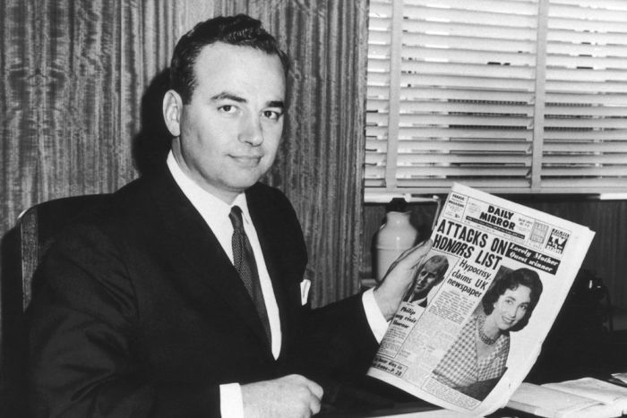 IMAGE: RUPERT MURDOCH PICTURED IN MAY 1960 AT THE TIME OF HIS ACQUISITION OF SYDNEY'S DAILY MIRROR. (KEYSTONE/HULTON ARCHIVE/GETTY IMAGES)

Although regulation and deregulation over the last 30 years were supposed to open up the Australian media to greater diversity, the largest media proprietors have been the greatest beneficiaries of attempts at reform.
'There are very few places where the people who are the beneficiaries of regulation get to determine how the regulation happens to quite the same degree that it happens in the Australian media landscape,' says Dodd.
'There have been situations in the last few years where communications ministers have said, "We'll only do this if all of the media owners agree to it," or, "Why don't you all talk amongst yourselves, sort out what you want to do, and if you come back with a consensus then we will get on with doing it." We've been bending over backwards to support media proprietors pretty well since the 1950s.'
'I do think that the interaction between media proprietors in Australia with politicians is different to other countries because of one very important difference, and that is that we have very high levels of media concentration in Australia compared to other countries,' adds Carson.
'If we are looking particularly at print, the two largest proprietors, or even if you take the top three, have a 98 per cent reach of audience across Australia. That is tremendously influential.
'Now, some might say that's not such a big deal because people don't read newspapers anymore, but they are reading the content that ends up online, either directly through those organisations' news sites or through the way their information is aggregated and used by other digital sites that the audience might be looking at.
'That makes them very powerful. And if you have a media organisation that has a particular political partisan bent and is determined to either favour or disfavour a political party or a politician, they have the eyes and ears of a very large number of Australians and can assert reasonable control.'
Earlier this year, Malcolm Turnbull, as minister for communications, proposed further deregulation that would have allowed metropolitan TV networks to merge with regional stations and media owners in major markets to publish newspapers while holding both radio and TV licences.
'The main reasons that drive this level of deregulation are the new elements that have come into play—the so-called content services enterprises, the Googles, the Apples, the Netflixes,' says Stuart Cunningham, professor of media and communications at Queensland University of Technology.
'It was considered, in the rationales given for the mooted changes in March this year, that the Australian media, the established media, the traditional media, are under great pressure, they are under advertising pressure, they are under pressure for the consumer's attention, and they need as much flexibility as possible to deal with those challenges.'
'Turnbull always said, "I'm not going to recommend anything until I get consensus." The problem is that there has never been full consensus around some of these changes for all sorts of reasons. The principal opponent here was Kerry Stokes, and the reason that he refused to back the abolition of the cross-media ownership rules without a wider package was that he saw it as being of greater advantage to his rival, the Nine Entertainment Co, because Nine was lining up to merge with Southern Cross Media, which would have made for a much bigger company, a much more economically powerful company than Stokes'.'
Since Turnbull became prime minister, the new minister for communications, Mitch Fifield, has indicated that he's dusting off plans for possible reform of media laws and that he will not be waiting for consensus. Turnbull's proposals were not endorsed by then prime minister Tony Abbott. It's unlikely that the current prime minister will prove to be as resistan

