60 Minutes’ Beirut crisis shines spotlight on its story payments

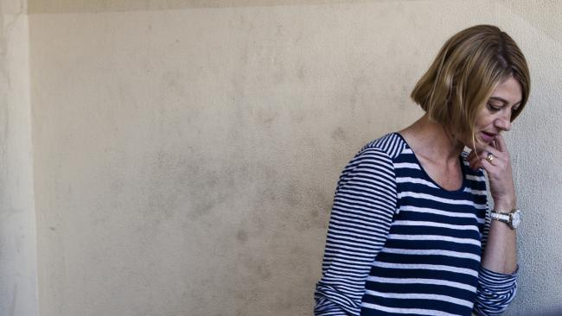
60 Minutes reporter Tara Brown leaves prison in Beirut on Wednesday, but her program and network are dealing with the aftermath of the ill-fated child ‘recovery’ operation.

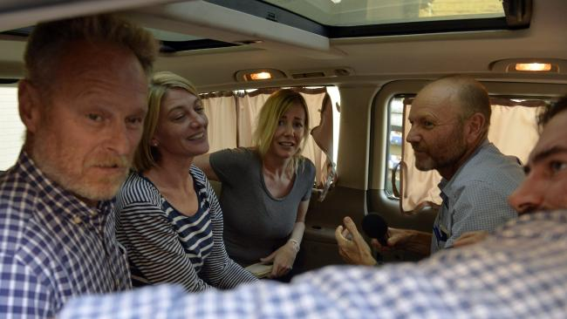
The 60 Minutes crew and Sally Faulkner, center, celebrate their release.

It was over a beer in the Channel Nine bar in Sydney that Peter Meakin, the legendary head of news and current affairs, came out with one of his famous zingers.

We’d been having a discussion about chequebook journalism — whether it distorted journalism or was an inevitable part of life. I was a new reporter on the Sunday program, where we would proudly — sometimes pompously — declare that we didn’t pay for stories or interviews. That didn’t always go down well with our colleagues at 60 Minutes and A Current Affair, who regularly paid for stories but claimed that the massive ratings and therefore revenue they were bringing in allowed us “pointy heads” at Sunday to have a program.

Under then chief executive David Leckie, Peter Meakin managed this broad church. He was as equally fierce a supporter of the two prime-time juggernauts which paid for stories as he was of Sunday, the earnest bunch down in our little cottage who, year after year, delivered Walkley awards to the network.
“Listen,” Meakin said after he’d listened to my argument against chequebook journalism. “I’ve got a cathedral (Sunday program) at one end of this block and a brothel (60 Minutes) at the other.” When I rang Meakin yesterday to check the quote, he said it was a lighthearted reference to how Sunday saw itself. “At that time I was in charge of both programs so I’d walk from the 60 Minutes cottage to the Sunday cottage where I found something of a monastic atmosphere,” he says. Following the debacle involving 60 Minutes in Lebanon this week, chequebook journalism is now under the microscope.
Nine paid money to begin the whole sorry story and paid money to end it.
Compare and contrast the fate that befell another Australian journalist, Peter Greste, spent 400 days in jail in Cairo. His employer, Al Jazeera, would not pay any money to Egyptian authorities and therefore Greste went through the excruciatingly-slow legal system. Yet the four 60 Minutes staff were out in just two weeks — an astonishingly short time for something of this complexity. Chequebook journalism was turned into chequebook justice .Nine has confirmed money was paid to get its people out of Beirut — they call it “compensation”. Soon after joining Nine I saw first-hand the relentless ratings culture. It was a Monday morning and a producer I knew from 60 Minutes was clearly delighted as he stood in the cafeteria. As I joined him in the queue for a coffee, he said: “Look at this!” It was 2001 and I was new to television, having joined Channel Nine’s Sunday program, where I eventually became executive producer.

The 60 Minutes producer showed me a piece of paper — graphs, numbers and times. He was showing me the ratings from the previous night’s 60 Minutes — but not just overall audience numbers but a minute by minute breakdown. “We smashed Seven,” he said with delight. I noticed a big spike at one point. “What’s that?” I asked. “That’s when she cried,” he replied, referring to a woman interviewed on the program who at one point had broken down in tears — TV gold. So I entered the world of commercial television.

In the wake of the Beirut debacle the real question now is whether Nine and its arch competitor Seven are prepared to seriously examine the culture that has led to the madness of paying money relating to the kidnapping of two children in Beirut. The signs from within Nine are not positive — one Nine heavyweight told me this week he could see nothing wrong with what 60 Minutes had done. “These sort of things are going to happen from time to time if you do journalism,” he said.
And for many industry watchers Nine’s choice to conduct its inquiry into the whole episode raised eyebrows — apart from the company’s legal counsel, Rachel Launders, the other two people are Gerald Stone and David Hurley. Stone is the founding executive producer of 60 Minutes — which led the way in Australian television for paying for stories — and Hurley is a one-time executive producer of A Current Affairs, which regularly pays large amounts of money for stories.

According to one journalist who has worked for several international networks, Australia’s chequebook journalism culture eclipses even that of the US where networks have much larger budgets.
Hamish Macdonald, who once worked for the Ten Network in Australia and more recently as a roving correspondent for ABC America, believes it’s time for a stocktake. Now a Harvard fellow in the US, Hamish Macdonald tells The Australian: “As a journalist, instinctively I feel for the families of any other journalist who is overseas and finds themselves locked up. It happens with frightening frequency the world over.”

But Macdonald adds: “It is hard to imagine ever finding myself in the same situation as the 60 Minutes team with any of the networks I’ve worked with. “Whether working for ITN in the UK, Al Jazeera, Ten in Australia, or ABC America I can’t imagine a scenario in which any of those networks would ‘green-light’ a story like this, particularly if it did indeed involve any alleged financial transaction.
“Perhaps some of the questions being asked of the crew might legitimately be asked of a network culture, which sees the pursuit of ratings trump other concerns.”“Working in American network TV I would hear regular complaints from across the sector about being beaten to stories by Australian television, who are reputed to pay big money for stories. “They often gazump the American networks which tend to have much clearer codes of ethics, standards and practice, sometimes made publicly available.” But John Westacott, who ran 60 Minutes for 16 years until 2010, defends the program and its chequebook journalism.“People have been paying for information for as long as there has been information for sale,” Westacott says. m“Chequebook journalism is not a new phenomenon — anyone with any information wants a fee for it.”More generally, Westacott says 60 Minutes has been a key part of Australian life.
“It’s played an important role in the country,” he says. “In its heyday four or five million people would have been watching nationally on a Sunday, which was in the 1980s and 90s before pay-TV and the internet.” Westacott says his fear now is that the Beirut episode will give financial controllers a chance to cut the program’s budget. “It bothers me that merchant bankers are running the company with a tighter hand and they look at a program like this and see opportunities to curtail it.
“It (Beirut) just gives merchant bankers in the boardroom — when the money for good quality investigations is getting tighter and they’re happy to have kids out of university blogging on the internet — this just gives them an excuse to burrow into the budget”.

Meakin believes the Beirut situation is a one-off hit for 60 Minutes and will not damage the program’s longer-term image.

“It’s remarkable how much the audience is prepared to forgive the odd peccadillo,” he says.Nine has found itself in this crisis with two of the key people being relatively inexperienced.
The chief executive of Nine, Hugh Marks, has been in the job four months and the executive producer of 60 Minutes, Kirsty Thomson, has been in the job two months. For much of its time Nine was famous for stability and experience.
Meakin and Westacott for many years managed key programs answering to Leckie. Leckie was an experienced man whose gruff demeanour disguised an over-the-horizon judgment for anything that might get the network into trouble.Between them, the three had more than 60 years media and television experience — and it showed. Even if a suggested kidnapping in Beirut had gone past Westacott it’s unlikely it would have got past Meakin, who since leaving Nine helped take Seven to the top of the ratings and is now head of news and current affairs at Ten. “I think it’s a one off,” says Meakin. “They (Nine) will have their investigation and they’ll proceed with the program. “All this about how it’s the death knell of the program is nonsense.”
Meakin says “less than ideal things happen from time to time,” and both the program and the audience will move on.
“There are a number of things I’ve done and the programs have done that you wouldn’t want on your CV, and I don’t think anyone expects journalists to be infallible.”
Referring to 60 Minutes, Meakin says “if the same situation happened again people might behave differently.” What does it mean for chequebook journalism? “I don’t think it means anything for chequebook journalism, that is something that will survive this. “There are a number of cases where chequebook journalism has got interviews that would not otherwise have been got. “The idea people amend their stories to make them more glamorous I don’t agree with.”
Meakin says it’s possible no-one at Nine will lose their jobs over the Beirut story. “I wouldn’t be surprised if everyone survived,” he says. Westacott says he fears that now journalism at Nine will be under threat.
“My concern is for the freedom of journalists to undertake investigations and push issues that need exposing,” he says. “We now leave ourselves open when things like this happen to be monitored and controlled by the lawyers and the financial controllers.
“For a long time 60 Minutes had the broadest freedom to do any story we thought in the public interest and took a lot of time and money to investigation.” Westacott lists many of the big stories 60 Minutes has broken over the years — top of his list is how the Australian Federal Police, after 60 Minutes had found him, arrested notorious paedophile Robert “Dolly” Dunn and brought him back for trial.
This ended up with Dunn being sent to prison. He says the program also broke the medical scandal over Chelmsford and investigated then treasurer Paul Keating’s investment in a piggery.
“You can’t go around breaking these stories if you don’t have the freedom to investigate and they are expensive,” he says. Westacott says for Nine, journalism has made money.
“Kerry (Packer) realised that in quality tabloid journalism there was money to be made — an audience to be had, as The Age’s insight team and The Australian’s investigations show.
“What concerns me when there are hiccups, especially in this current climate, that there’s every chance that bean counters and in-house lawyers, who are nervous nellies at the best of times, will want David Attenborough fluffy duck stories.” In defending 60 Minutes’ brand of journalism, Westacott argues that American networks claim they do not pay for stories when they in fact make payments in kind — such as holidays. Around Nine, Westacott was considered the master of chequebook journalism.
When I rang him yesterday to check one story I’d heard that to get a story he once paid for a woman’s dental work, he laughed: “I’ve been accused of a lot of things but never fixing up someone’s teeth.”
He quickly adds: “But it’s a good idea!”

