1) Landscape
Type of photography that features large expanses of space, of large lands, or of the world. These images are meant to feature the grand scale of nature (and sometimes vast expanses of man-made features).
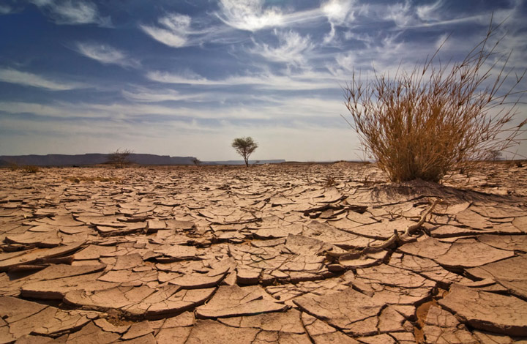

2) Fashion
Type of photography featuring fashion and clothing, often with professional female models. Entire industries are dedicated to fashion, which includes fashion magazines such as Elle, Vogue, or Vanity Fair.

3) Fine Art
Photography that is rooted in the artistic or subjective vision of a photographer, as opposed to representational photography (such as photojournalism) which accounts for unaltered reality.
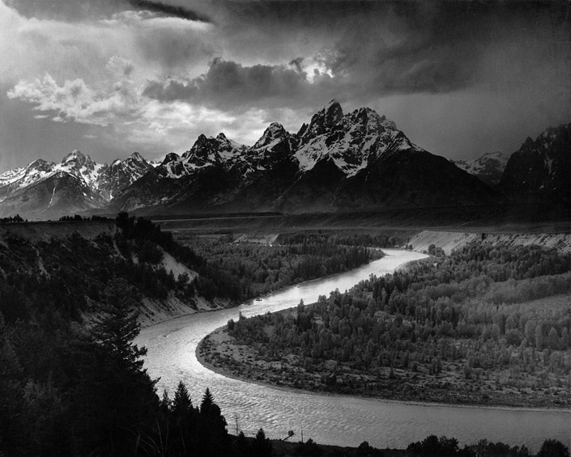
Ansel Adams’ The Tetons and the Snake River
4) Portraiture
Photography that is about portraying the mood, personality, and expression of a person or group of persons. The focus is usually the face, though a farther out zoom to a half- or full-body is sometimes done.

5) Wildlife
Type of photography that documents animals in their natural habitat. It is often very challenging to photograph animals, since not only does a photographer need to be spot on with their technical skills but they also need to approach animals without being detected.
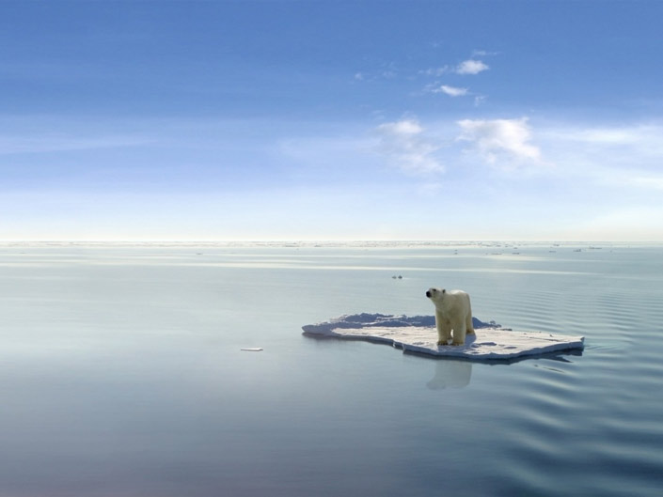

6) Wedding
Wedding photographers utilize a variety of photography styles to provide wedding coverage. Completely wedding coverage require the photographer to be good at macro, portrait, photojournalistic, fine art, fashion, landscape, and action/sports photography.

7) Macro
Type of photography that depicts extreme close up shots of small objects. By doing so, the subjects can appear to be much larger than life size.
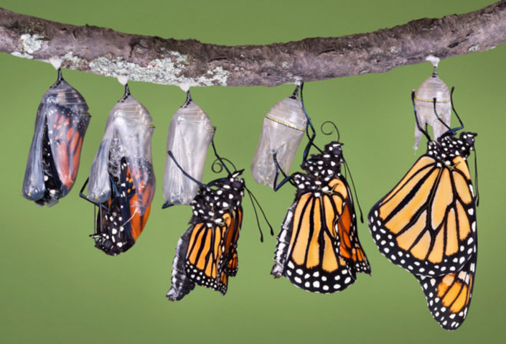
8) Photojournalism
Photography that documents an event or story as it is unfolding. The photographer is to uphold fidelity to reality, to be honest and impartial while telling the story.

9) Architectural
Photography that portrays the feeling of being around a built environment. It is about portraying aesthetically pleasing buildings and structures.
10) Black & White
Photography that features images in black and white, i.e. shades of gray, in which the appeal lies in the monochromatic character of the style.

Special Mentions
Abstract: photography that is untraditional and breaks the rules, but no true meaning is necessarily meant in the photograph. Subjects are not portrayed normally. Often they comprise of details, patterns, lines, shapes, colors that are in themselves the subject.
Aerial: type of photography that is unique in that the images are taken from aircrafts or otherwise flying crafts, which results in awe-inspiring high angle photographs.
Astrophotography: photography through a telescope, portraying outer space.
Artistic: photography which focuses on creative composition.
Commercial: photography in which the photographer is paid for images for commercial use (as opposed to works of art).
Conceptual: photography in which an idea is preconceived and the photographer tries to convey that idea with an image. Advertising or stock photography are examples of conceptual photography.
Concert: concert photography is a sort of photojournalism that is all about documenting live music performances of bands and musicians. The environment is most disadvantageous for a photographer: dark environments, rapidly changing lights, and wild crowds. Technical competence is the minimum requirement for concert photography.
Erotic/Nude: erotic photography is a type of portraiture that is sexually suggestive in nature but claims aesthetic and artistic merit. Nude photography is not necessarily suggestive, since the subject may not be in an erotic pose.
Event: event photographers use a mixture of photography styles to provide photojournalistic coverage of special occasions, parties, reunions, and corporate retreats.
Family: portraiture of a family (i.e. multiple-person or group portraits)
Maternity: photography that mixes portraiture and conceptual photography to document a woman as she goes through pregnancy.
Glamour: type of photography in which female subjects are conveyed in alluring manner. Sexual arousal is not the goal, so glamour photography is not as overt sexual as, say, in pornographic materials.
Infrared: type of photography in which the equipment is sensitive to infrared light as opposed to visible light.
Kirlian: photography that comprises of a collection of techniques to photograph the phenomenon of coronal discharges, resulting in images that appear to have an aura.
Sports: type of photography is intended to document sporting events as they unfold. Less emphasis on artistic concepts and more on the technical skill required to capture precise and brief moments.
Still Life: photography of inanimate objects.
Street: type of photography that is photojournalistic in nature. The point is to document the human condition in public. Despite the name, being on the streets or in an urban environment is not required.
Surreal: photography that is based on imagination. Photos are often disorienting, hallucinatory, and bizarre.
Travel: photography which involves documenting the landscape, culture, custom, people, and history of a destination location.
Underwater: photography that is taken underwater with cameras equipped with special waterproof housing.
Urban & Rural: photography that emphasizes urban or rural environments.

