Year 11 Unit Two

Outcome One Exercise 3

Social Awareness Advertisement

Advertising is one of the most pervasive and all-encompassing forms of communication in the modern world. Newspapers, magazines, television, radio and the Internet all convey advertising messages to consumers. While businesses primarily use advertising to deliver information on their products and services, advertising methods also raise awareness of social issues. Powerful images, resonant music and well-worded text can evoke feelings in viewers to promote societal changes.

Create a social awareness advertising campaign based on one of the following

The environment
Anti Smoking
Safe Work practice
Cyber Bullying
School Bullying
Mental Health
Anti Drug awareness

Option A Write and produce a 30- 60 second Social Awareness television advertisement that raises awareness and encourages action:

This can either be a group production (2-3 students) or an individual production

Ref manganmedia.com year 11

Option B : Create 2 A3 Visual Social Awareness Advertisements

This task can be completed in pairs or individually or i
n

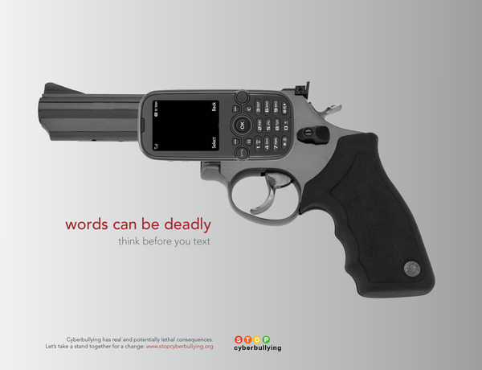d

