TREATY Yothu Yindi
1988 marked the bi-centennary of British settlement in Australia, and it was in this year that Prime Minister Bob Hawke attended the Barunga Festival in a small Indigenous community south of Katherine. There, the Chairmen of both the Northern and Central Land Councils, Galarrwuy Yunupingu and Wenten Rubuntja, presented the Prime Minister with the Barunga Statement.
The Barunga Statement called on the Australian Government to recognise the rights of Indigenous land owners and to formalise a Treaty with them. It was bordered with Yol\u and central Australian designs, and was modelled on the Yirrkala Petition (1963) which the previous generation of Yolngu leaders had sent to the House of Representatives in protest against mining on the Gove Peninsula. Galarrwuy and Mandawuy’s own father was a signatory to this petition. On receiving the Barunga Statement (1988) at the Barunga Festival, Prime Minister Hawke vowed that his government would enter into a Treaty with Indigenous Australians by 1990. However, this promise would never be realised.
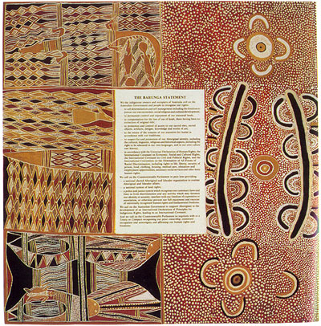

"Treaty” was composed by Yothu Yindi in collaboration with Paul Kelly and Midnight Oil to protest the failure of the Australian Government to honour the Prime Minister’s promise to Indigenous Australians at the Barunga Festival. The song was remixed in Melbourne by Filthy Lucre in 1991 and rapidly climbed the Australian charts as did the album on which it was released, Tribal Voice (1992).
“Treaty” is also innovative in its incorporation of an historic djatpangarri song item. djatpangarri is a style music and dance that was pioneered by young men at Yirrkala in the late 1930s and was performed there for popular entertainment until the early 1970s. For local Yol\u audiences, “Treaty” has reintroduced the young to a fun form of song and dance that their parents and grandparents enjoyed in their youths while the song reminds older listeners a time before the advent of mining on the Gove Peninsula. On Tribal Voice (1992), “Treaty” is preceded by another historic djatpangarri item, “Gapu [Water],” which shares a similar melodic structure.
Aaron Corn

