PRODUCTION ELEMENT Lighting
Lighting not only allows an audience to see the action in a film, it shapes and frames this action drawing attention to objects characters and actions thus illuminating far more than what is on the screen.
The colour and quality of the light positions the audience to read the shot or scene in a particular way. Lighting works both literally and symbolically employing both visual codes and conventions to suggest interpretation In the construction of film and television narratives much energy and expense is devoted to making most scenes look natural, that is how we would imagine it would look in real life. This is called naturalistic lighting.
Expressive lighting is a style of lighting used to represent greater meaning in relation to characters, settings, mood and themes. Example- a character is lit from behind making them glow, perhaps they are the angel that will save the situation. When a character is lit from below they may appear aggressive.
The direction that we view a light source from has a profound effect on our perception of it, and on how the objects in a scene will appear. Choosing which direction your main light is coming from is one of the most important decisions you can make since it will have a great deal of impact on how a scene will appear, and also on the emotions your image will convey.

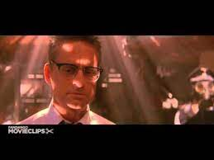
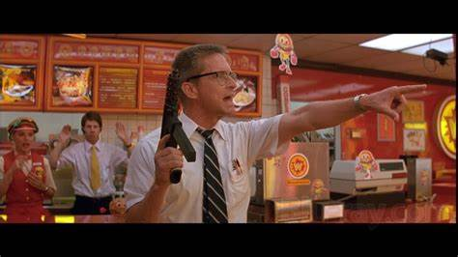
Lighting Positions
Frontal Lighting
This is where the light source is directly behind the viewer's point of view. It is most commonly seen in flash photography and is often fairly unappealing if the light source is hard - there are exceptions and in some situations very attractive images can come from soft frontal lighting. Front lighting does little to reveal form or texture since the shadows are mostly hidden from view; as a result it can make things look flat. However soft diffused frontal lighting can also be quite flattering to some subjects for this very reason - it can help conceal wrinkles and blemishes and so is quite often used in portrait and product photography

Side lighting
is very good for showing form and texture and lends a threedimensional quality to objects. Shadows are prominent and contrast can be high as a result. Side lighting can be used to throw dramatic shadows onto surfaces such as walls and create atmosphere. Side lighting is generally attractive and is often used to great effect: it is the kind of lighting encountered at the beginning and end of the day and as such is often seen in films and photographs
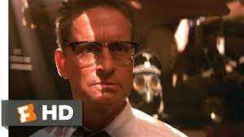

Back lighting
is where the viewer is looking into the light source, and objects will have their lit sides facing away from us to appear either as silhouettes or darkly lit by the fill light. It is usually a high contrast situation and can often look very atmospheric and dramatic. If the light source is at a slight angle relative to our point of view objects will have a rim of light defining one or more of their edges, the harder the light the more pronounced this rim will be. Backlit scenes usually contain a lot of shadow unless the light source is very soft. Most of the time the image will be predominantly dark with dramatic pools of light. The rim lighting that occurs in this situation can be very useful for defining forms among the shadows. Another feature of this kind of light is that it reveals transparency, translucency and any fine detail or texture along rim-lit edges. This kind of light is very effective for lending drama to an image

Top Lighting
Top lighting is a slightly more unusual situation, although it is common in overcast daylight. It can also be encountered in sunshine at midday, in some interiors and in other situations such as stage lighting. In soft light it is an effective way of showing form. Under hard light it can lend an air of mystery by casting dramatic shadows which conceal most of the forms beneath them: for instance people directly underneath hard lights will have black holes for eyes since their eye sockets will be in total shadow
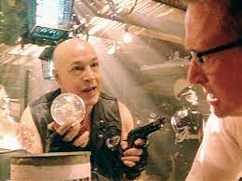

Below Lighting
If lighting from directly above is rare, then doing so from directly below is even more unusual. In a natural context this might happen if someone is standing over a campfire, or holding a torch. Reflected light can also come from below, from water for instance. It would definitely lend a strange appearance to even the most familiar things since what is usually seen in light and shade would be reversed (think of a person shining a torch onto their face from below: the shadows appear to be upside down). Again, the very rarity of this kind of lighting can be used to creative effect. We instinctively recognise things that don’t seem right, and this can be used to create specific moods by manipulating the lighting to convey emotions and responses

High key
High key images have a predominance of white or very light tones and tend to look light and airy. High key lighting is often (but not always) soft, and detail is generally low. In nature high key lighting is found in fog and snow, where even shadows are light due to the amount of reflected light bouncing around. Low key Low-key images have by their very nature very little light in them. Contrast is usually high and the lighting hard. Low-key lighting can create a very moody atmosphere and is often used to this effect. The most obvious setting for low-key lighting is nighttime, but it can also be found in other situations such as storms and in interiors. Exaggerated use of low-key lighting can be found in horror films, where underlighting (placing a light under a face or an object) gives a dramatic, often-distorting effect. Low-key lighting is often seen as expressive

