Sexting and cyber bullying behind review of mobile phone use in school
- Sep 7 2018 at 11:00 PM
- Updated Sep 7 2018 at 11:00 PM
- https://www.afr.com/news/policy/education/sexting-and-cyber-bullying-behind-review-of-mobile-phone-use-in-school-20180907-h152pk
- 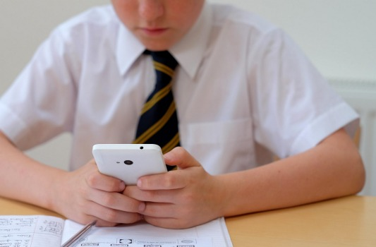
The use of mobiles at school has been described as 'one of the most difficult problems' plaguing parents. Alamy Stock Photo
- by Robert Bolton
Banning mobile phones from school would be like trying to ban Biros according to leading educationalist, John Hattie, which follows the NSW government announcing terms of reference for a review of phone use in school.
Professor Hattie said if the review recommended a ban it would be impossible to enforce and go against the idea of adapting to new technology.
Psychologist Dr Michael Carr-Gregg has been asked to make a recommendation on what the state government called "one of the most difficult problems" plaguing parents.
Cyber bullying, sexting and access to online harm were the big issues identified by the states' Education Minister Rob Stokes.
Clinical psychologist at Macquarie University, Danielle Einstein, says there is a lot of work to be done on the relationship between mobile phone use and childhood anxiety.
Terms of reference include whether restrictions should be imposed on smartphone use in primary schools or among children in certain age brackets.

Executive director of the Council of Catholic School Parents, Linda McNeil, said the review was a good initiative.
"This is something that is driving parents crazy,the effect of social media on their kids. We know from research that as soon as the use of smart phones became endemic, rates of depression among children took off."
In the case of Catholic schools she said phone use decisions would probably come down to the decision of individual schools.
Senior research fellow at the Centre for Independent Studies, Dr Jennifer Buckingham said it did not need a government ban for schools to prohibit phone use and principals at a number of schools have already ruled them off-limits during school hours.
"The evidence on mobile phone use on psychological well-being seems stronger than its impact on academic performance. But the likelihood is if you use phones in classrooms, the risks will outweigh the benefits. It's very difficult for a teacher to control what happens every time they turn their back,"
Dr Buckingham said it may be better to let schools develop their own policies. Parents were aware of the issues and any action to limit children's time on phones would have to be a partnership between schools and parents.
Childhood anxiety
Last Monday the French government banned mobile phone use at school for all children up to age 15.
"France has had a few experiments in terms of being progressive but they have not worked out," Dr Buckingham said.
"There is evidence that just having a mobile phone next to you is distracting and using them can impair cognitive ability and memory."
Clinical psychologist at Macquarie University, Danielle Einstein, said there is a lot of work to be done on the relationship between mobile phone use and childhood anxiety.
"It's about the excessive reliance on the phone to calm worries. Using the phone gives a little bit of info and quells anxiety momentarily. But children need to learn to tolerate uncertainty. There are times when you can't get reassurance," she said.
"My interest is in being able to sit with uncertainty, being able to tolerate not looking at your phone. The science is not well enough developed to pin it down, but we should look at the possibilities. I hope the review will consider issues like this."
Dr Einstein said a number of studies had shown how mobile phone use and social media affected well being. A study of Facebook use demonstrated a decline in well being during real time use. Another study had highlighted the role of envy in compromising mood when interacting on Facebook.

