FILL IN THE GAPS- DIGITAL SINGLE- LENS REFLEX CAMERA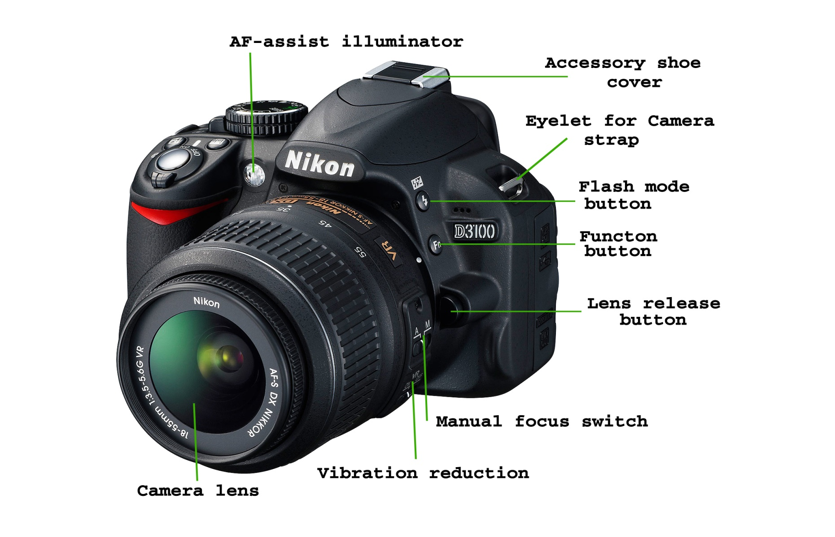Write a short desrciption below of the role of each of the above labels.
1.
2.
3.
4.
5.
6.
7.
8.
9.
10.

