There are a number of reasons why we believe it is necessary to regulate the media.
• One of the reasons that we regulate the media is the possibility of copycat behaviour. Both the FreeTV Australia and the Advertising Standards Bureau have guidelines for the advertising of food and beverages to children which state that they should not promote an ‘inactive lifestyle’ or ‘unhealthy eating or drink habits’. FreeTV Australia and Commercial Radio Australia have guidelines relating to the portrayal of suicide. Commercial television and commercial radio codes of practice have guidelines pertaining to the portrayal of women, indigenous people and cultural diversity because it is believed the media should not promote prejudice and intolerance.
• To protect children from potentially harmful or damaging media images.
• To protect adults from seeing unsolicited material that is likely to offend.
• In Australia, there are minimum requirements for the amount of Australian content on television and radio, a reflection of the belief that overseas content may erode our cultural identity. The Australian Content Standard (2005) mandates a 55% quota of Australian content on television between 6 am and midnight. Similarly, commercial radio stations must broadcast minimum quotas of Australian music.
• There are controls on foreign ownership in the media because the media is considered a ‘sensitive sector’ and it is important that the media is distinctively Australian.

THE AUSTRALIAN COMMUNICATION AND MEDIA AUTHORITY
The ACMA is a government body responsible for regulating broadcasting and online content in Australia. Its responsibilities include:
• promoting self-regulation and competition in the communications industry, while protecting consumers and other users
• fostering an environment in which electronic media respect community standards and respond to audience and user needs
• managing access to the radiofrequency spectrum
• representing Australia ‘s communications interests internationally.
The ACMA has developed codes of practice for television and radio in conjunction with the industry FreeTV Australia and Commercial Radio Australia. These codes govern the content of television and radio in Australia.
The ACMA also helps to regulate the ownership of commercial media organisations in Australia through a register of controlled media groups.
Under current media ownership laws in Australia:
• foreign investment in the Australia media is permitted but the mass media is considered a ‘sensitive sector’ and any foreign investment, regardless of its size must be approved by the Treasurer

NATIONAL CLASSIFICATION SCHEME
The classification of films, video games and publications in Australia is the responsibility of the Attorney General’s Department. A Classification Board and Classification Review Board make decisions about the classification of films, video games and publications which are available for sale and hire in Australia.
Under the Commonwealth Classifications Act, the following matters are taken into account when classifying films, video games and publications:
• the standards of morality, decency and propriety generally accepted by reasonable adults;
• the literary, artistic or educational merit (if any) of the publication, film or computer game;
• the general character of the publication, film or computer game, including whether it is of a medical, legal or scientific character;
• the persons or class of persons to or amongst whom it is published or is intended or likely to be published.
Classification decisions are made according to the following principles:
• adults should be able to read, hear and see what they want;
• minors should be protected from material likely to harm or disturb them;
• everyone should be protected from exposure to unsolicited material that they find offensive;
• the need to take account of community concerns about: depictions that condone or incite violence, particularly sexual violence; and the portrayal of persons in a demeaning manner.
In Australia, there are a number of classification categories, including: G, PG, M15+, MA15+, R and X. If a film, computer game or publication is deemed inappropriate by the Classification Board, it is refused classification and prohibited from sale in Australia.

CLASSIFICATION CONTROVERSIES
The classification of films and video games often attracts controversy.
One of the difficulties faced by the National Classification Scheme is the sheer volume of content that needs to be classified. In 2016, Netflix global public policy manager Josh Korn told IT News that television programs might screen later in Australia to accommodate the time it takes to have these classified by the Classification Board.

“As Netflix increases its investments in content, more and more titles will need to be given an Australian classification,” Mr Korn said. “However, there are significant obstacles associated with classifying large volumes of content. Processing delays could result in content being premiered later in Australia than in other Netflix markets.”
In 2017, the Australian government partnered with Netflix to create a tool that would allow the streaming giant to classify its own content. The Classification Board started reviewing some of the self-classified titles, including the program 13 Reasons Why, after many criticised the program’s depiction of suicide.

Between March 2014 and June 2015, the Classification Board refused classification for 220 video games, four times more than they had in the previous twenty years. These games included titles like Douchebag Beach Club, Drunk Driver and HoboSimulator. As of July 2015, International Age Rating Coalition tool will be used to rate the enormous number of video games being released digitally.

In 2012, there was controversy of the classification of Ridley Scott’s Prometheus. Despite the fact that the film featured graphic science fiction violence, it was given an M classification which meant that children under the age of fifteen could watch the film.

In 2013, actor James Franco weighed into the classification debate when the film I want your love was refused classification by the Classification Board for its depiction of homosexual sex. “Because films have been banned because of sex, sex and films hasn’t had a chance to grow and become a sophisticated storytelling device,” he said. “And frankly adults should be able to choose. They’re not going in blind. I don’t know why in this day and age, something like this — a film that is using sex not for titillation but to talk about being human — is being banned. It’s just embarrassing.”

In Australia, the classification of video games was a source of considerable controversy. Until 2011, when the Attorney Generals agreed to introduce an R18+ category for video games, games that exceeded the MA15+ classification were deemed unsuitable for an Australian audience. Games like Left 4 Dead 2 and Manhunt were refused classification by the Classification Board. In 2010, the Attorney General’s Department conducted a public consultation on the proposed introduction of an R18+ classification. The results were overwhelmingly in favour of its introduction. “More than 58,400 people responded to the call for submissions on the proposed new adult only category,” said Minister for Home Affairs Brendan O’Connor. “That’s an enormous response and I thank everyone who gave their views. Of those who responded, 98.4% voiced support for an R18+ computer game classification.”

The Australian Government Is Letting Netflix Classify Its Own Shows
Dec 7, 2016, 2:00pm

Netflix recently made an appeal to the Federal Government to allow a self-classification system, bringing streaming services on par with broadcasters and the digital games industry - ultimately meaning Aussies don't have such huge delays between when shows become available, and when we get to see them.
And it has worked.

Back in April we reported thanks to the sheer amount of content being added every month and Australia's lengthy classification process for content streaming services, there was a risk of Australians not getting the latest episodes of our favourite shows on time.

Now today the Federal Government has announced a 12 month pilot of what it describes as a "world-first classification tool" designed to streamline the process of classifying Netflix content for Australian audiences. Netflix has been working with the Federal Government on this tool, combining the streaming service's technology and Australia's classification advisories.

If this sounds familiar, it's because there's already a pilot operating for self-classification of digital content in Australia. The International Age Rating Coalition tool assesses online and mobile games on Google Play, the Microsoft Windows Store and the Nintendo eShop, and has churned through over 500,000 classifications since its pilot began in May 2015.

According to the Government, this is the first time in the world that a self-regulatory tool is being used for film and TV. But don't think this means it will all be hands-off. Decisions will be reviewed (and if necessary, revoked) by the Classification Board to "assess integrity" and make sure the ratings are meeting Australian community standards.

Netflix failed to flag 'strong suicide themes' for 13 Reasons Why
14 August 2018

- It took government intervention for Netflix to warn Australian parents about "strong suicide themes" in the first season of 13 Reasons Why.

The global streaming giant originally gave the confronting television series an MA15+ rating on the grounds it portrayed strong sex scenes and violence.

However, the Classifications Board reviewed the decision and ruled 13 Reasons Why should be restricted to people aged 15 years and over because of "strong suicide themes and sexual violence". As a result, Netflix amended its consumer advice for Australian audiences.

The ratings watchdog said parents should be warned about the strong suicide themes given the show depicts – in graphic detail – the method in which main character Hannah Baker kills herself, according to documents released under freedom of information.

A previous episode depicts the same actor, played by Australian Katherine Langford, being raped in a hot tub.

Mental health groups raised concerns about the first season of 13 Reasons Why - and so did the ratings watchdog.

Last year, Australia's peak mental health organisations raised concerns about 13 Reasons Why. Among their grievances was the fact Netflix did not list the contact information for local support services, as is widely done in Australia.

While the creators of 13 Reasons Why stood by their show – even pointing out they consulted with medical professionals – Netflix changed its approach for the release of the second season. This time around, viewers were directed to a website that listed the contact details for suicide prevention services.

Child and adolescent psychologist Dr Michael Carr-Gregg said the majority of young people who watch 13 Reasons Why won't be profoundly affected. But he said there is "definitely a contagion affect" that has been documented for people with pre-existing mental health conditions.

"A man rang me from Canberra not long after the show went to air and said his daughter had watched this without his knowledge or consent and said she had popped herself in the bathtub and [attempted suicide] in the same way as Hannah does in 13 Reasons Why," he said.

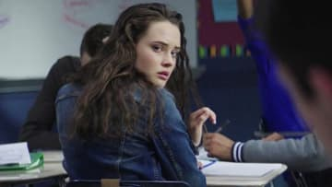

"I think the least we can do is give consumers adequate warning."

The Classifications Board randomly audits Netflix's in-house ratings. However, high-profile films and TV shows – as well as those perceived to be controversial – are automatically put under scrutiny.

A Netflix spokeswoman said the streaming giant will continue to work with the government watchdog in order to produce ratings that are "broadly consistent with classification decisions of the board and community standards".

The Department of Communications and the Arts declined to comment.

Should Netflix be forced to screen more Australian content?
9/05/2018

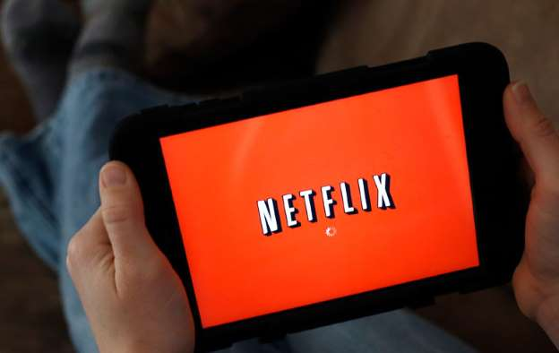
In recent months, the debate about the future shape of Australian culture has spilled out into the open, driven by a concerted campaign by industry groups, including Screen Producers Australia and the Media Entertainment and Arts Alliance, to “make it Australian”.
Find out more on Finder
Australian-made campaigns are nothing new. But the interesting aspect of the current push is that the industry is pressing for more regulation, not more money.

Screen Producers Australia (SPA) is the peak body for the domestic film and television production sector. SPA’s Matthew Deaner says that “reform of the regulatory model” to extend local content obligations to streaming video on demand (SVOD) is “the number one thing” that the industry is seeking.

“It’s about providing a level playing field and opening up opportunities fort the local production sector,” Deaner told Crikey. “There’s an industry capability argument there, you can’t have Australian content without an Australian industry, and vice versa.”

Keeping local screens Australian will be no easy task. The regulatory challenges of a rapidly moving industry are stark.

A good example is streaming video. As Australians lock in for hours of binge watching on Netflix and Stan, streaming video is rapidly becoming the dominant way for Australian audiences to watch movies and TV. That’s leaving the old regulatory system behind.
This graph by the University of Melbourne’s veteran media researcher Denis Muller from ACMA illustrates the issue. As Muller writes, “the trend away from broadcast and towards streaming services is accelerating, especially among younger people”.

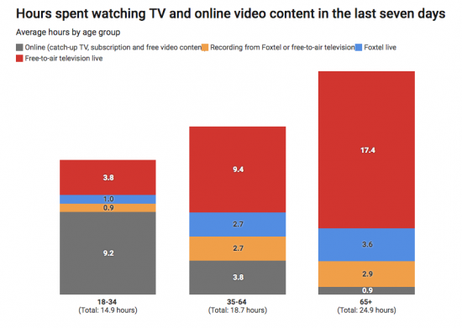
Younger audiences are increasingly turning off the TVs, and opening their laptops. Source: Denis Muller, based on ACMA data.

In the past, regulators protected Australian production with local content rules that forced broadcasters to screen a majority of Australian content in prime time. Broadcast television still enjoys a strong regime of local content protection — prime time TV must be 55% local content. (Even if it has been watered down in recent years by the notorious “Kiwi clause”, which allows New Zealand-produced TV to be counted as “Australian” for the purposes of the quota).

In contrast, streaming has no local content regulations whatsoever. The consequences for local producers are potentially dire. While Netflix boasts more than 7 million subscribers, Australian content on the American-owned service is negligible.

How negligible? Perhaps only a few per cent. RMIT research fellow Dr Ramon Lobato has looked at the proportion of local content in a submission to the government’s screen content review. After cataloguing approximately 3000 titles on Netflix and 1000 on Stan, Lobato discovered that Australian content was just 2.5% on Netflix, and 9% on Stan.

“The general trend is pretty clear,” he told Crikey in an email. “Local content makes up a small proportion of the overall content offering on SVOD services in Australia.”
Another crunch point is the problem of how to find Australian content: a dilemma the industry calls “discoverability”.

“Whether or not local content is recommended to users will depend on things like genre, cast, and other users’ viewing behavior,” Lobato explained. “In short, the ‘black box’ of recommendations is very difficult for researchers and policymakers to study.”

Labato adds that “given the market power of Netflix in Australia, I think a quota system of some kind — as per the EU model — is certainly worth considering as part of the regulatory mix.” But, he cautions, “there is a lot of devil in the detail here that we would need to carefully consider as part of a long-term policy process.”

Deaner points out that European regulators have moved to address the streaming services with new content rules. “In Europe, they have a 30% library quota on SVOD, and they have an expenditure obligation, which is on new content, so that creates commissions,” he pointed out. “The third obligation is promotion, so the SVOD services have an obligation to promote local content, on the landing page.” In contrast, Australia has no local content regulations on streaming video platforms.

The screen producers argue that a 10% local content obligation on streaming services could result in as much as $100 million in new investment into the local sector. “That obligation on Netflix is around the same amount of money that Foxtel spends,” Deaner argued while cautioning that these are “back of the envelope numbers”.

